# Assignment 4

## Probabilistic and Unsupervised Learning

## Yuan Zhang

## SN: 17044633

## [ucaby02@ucl.ac.uk](mailto:ucaby02@ucl.ac.uk)

## Dec 4th, 2017

## Deriving Gibbs Sampling for LDA

#### Joint Probability over x and z

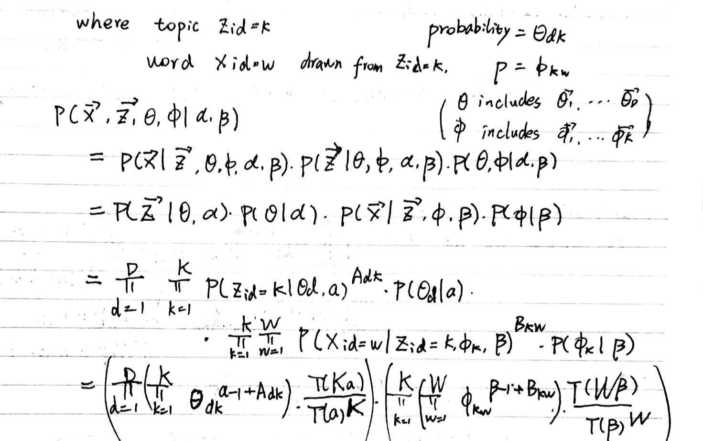

#### Derive the Gibbs Sampling

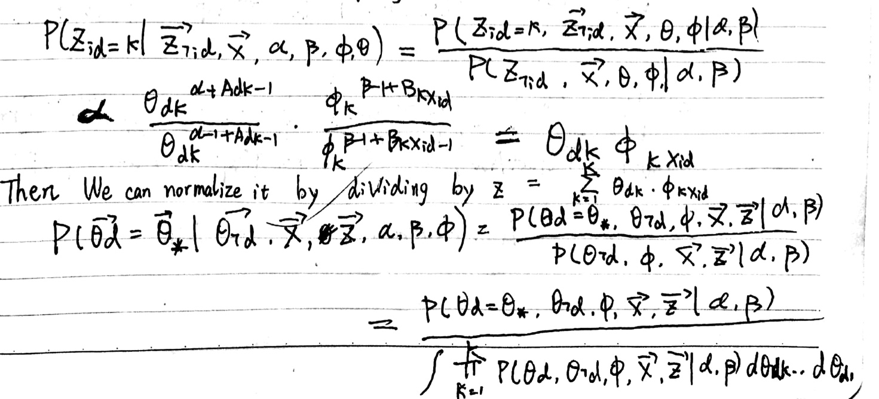

#### Macintosh HD:Users:yuanzhang:Desktop:WechatIMG162.jpeg

#### Integrate out THETA and PHI

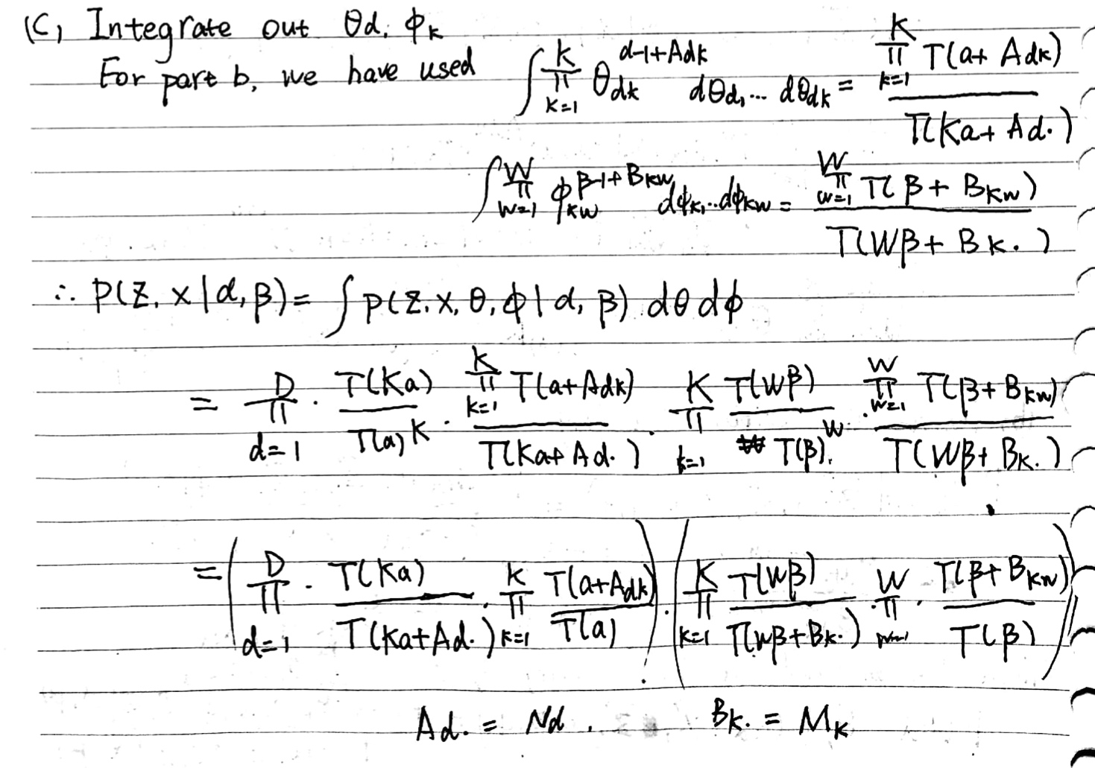

#### Derive the collapsed Gibbs Sampling

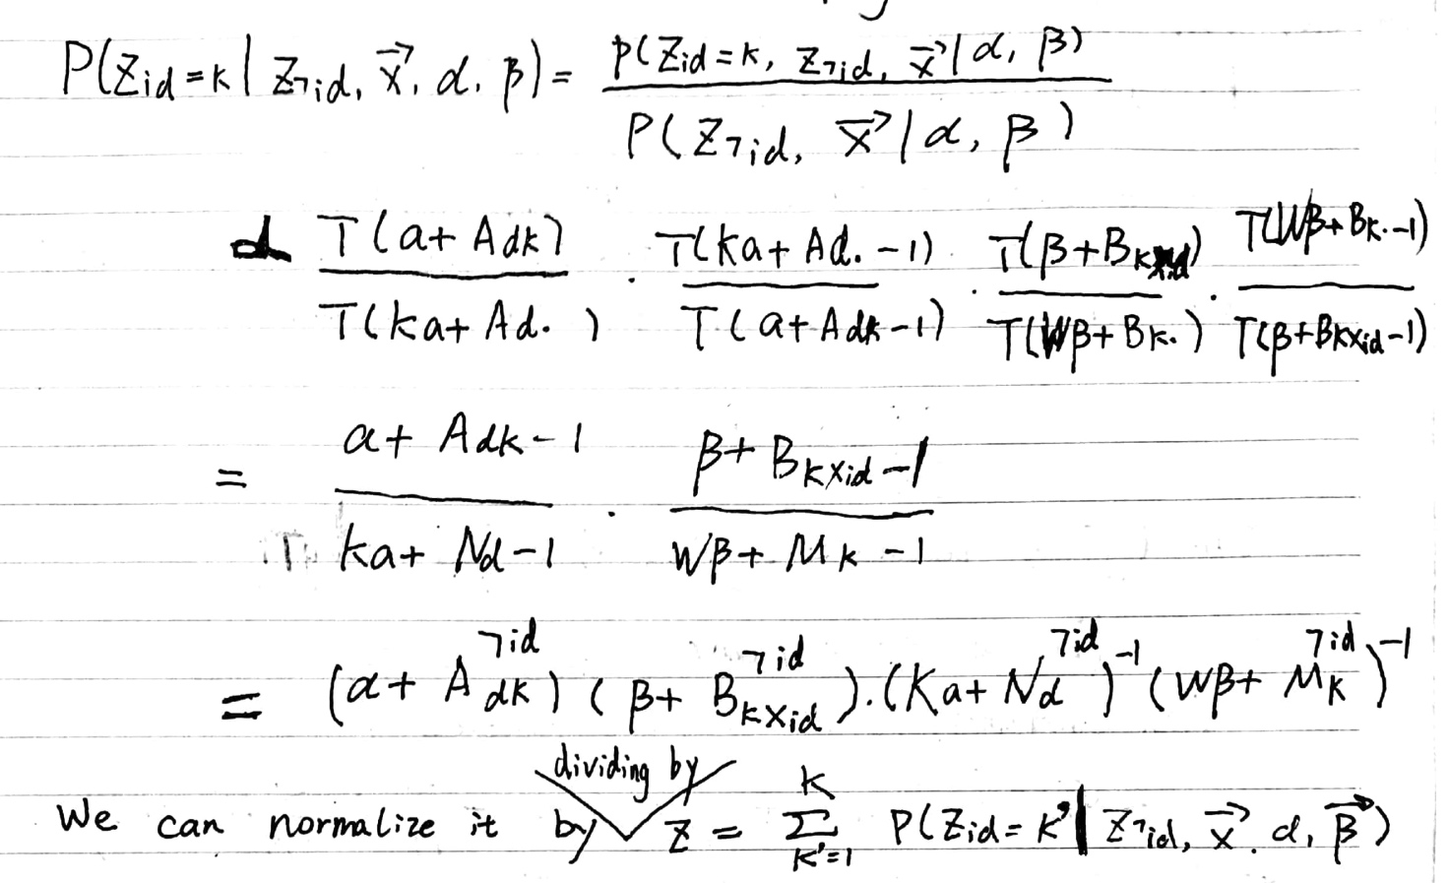

#### (e) Hyper Parameters

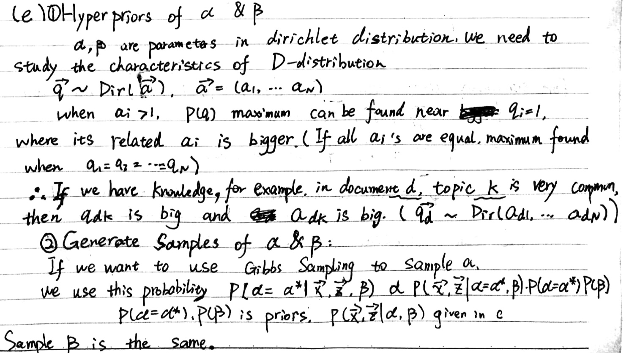

## Decrypting Messages with MCMC

#### (a) ML estimate

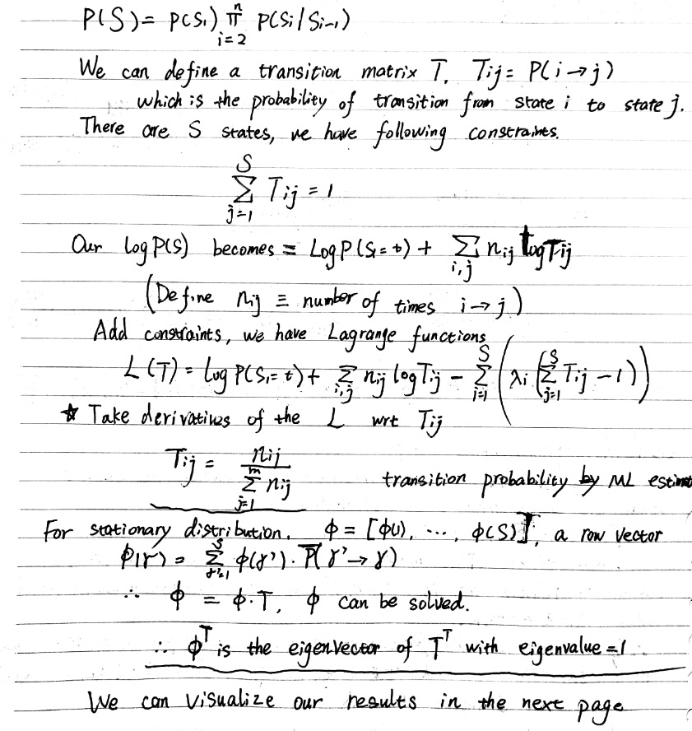

#### Code Parts: parta, update.

% parta.m

% estimate transition stastics using <war and peace>

clc,clear;

% read symbols

fid = fopen('symbols.txt','rb');

symbols = fgetl(fid);

while(~feof(fid))

symbol = fgetl(fid);

symbols=[symbols;symbol];

end

fclose(fid);

% maximum likelihood to estimate transition matrix

S = length(symbols);

T = ones(S+1,S+1); % add one symbol for accident.

fid = fopen('war&peace.txt','rb');

txt = fgetl(fid);

T = UpdateT(T,txt,symbols);

if(length(txt)>0) last = txt(end);else last = []; end

while(~feof(fid))

txt = fgetl(fid);

txt2 = [last txt];

T = UpdateT(T,txt2,symbols);

if(length(txt)>0) last = txt(end);else last = []; end

end

fclose(fid);

T = T(1:end-1,1:end-1); % ignore the strange symbols(like French words.)

Tnorm = diag(1./sum(T'),0)*T; % makes row sum = 1;

Tnorm(isnan(Tnorm)) = 0;

figure,imagesc(Tnorm),colormap(flipud(gray));

xlabel('second letter');ylabel('first letter');

% calculate stationary distribution

[V,D] = eig(Tnorm');

d = diag(D);

[~,ii] = min(abs(d-1));

pi = V(:,ii)';

pi = pi/sum(pi);

figure,imagesc(pi),colormap(flipud(gray));

xlabel('letters stationary distribution');

function Tnew = UpdateT(T,txt,symbols)

% calculate this new line and update our transition matrix

len = length(txt);

Tnew = T;

if(len==0) return; end

S = length(symbols);

states = zeros(len,1);

for i=1:len

id = find(symbols==txt(i));

if(isempty(id))

states(i) = S+1;

else

states(i) = id;

end

end

for i=1:length(states)-1

m = states(i);

n = states(i+1);

Tnew(m,n) = T(m,n)+1;

end

end

#### Result:

Transition matrix:

#### Macintosh HD:Users:yuanzhang:Desktop:UCL:term1:UnsuperviseLearning:Asst4:code:q2:untitled.jpg

Stationary distribution:



(Black means big values, white means small values.)

#### (b) MCMC sampler

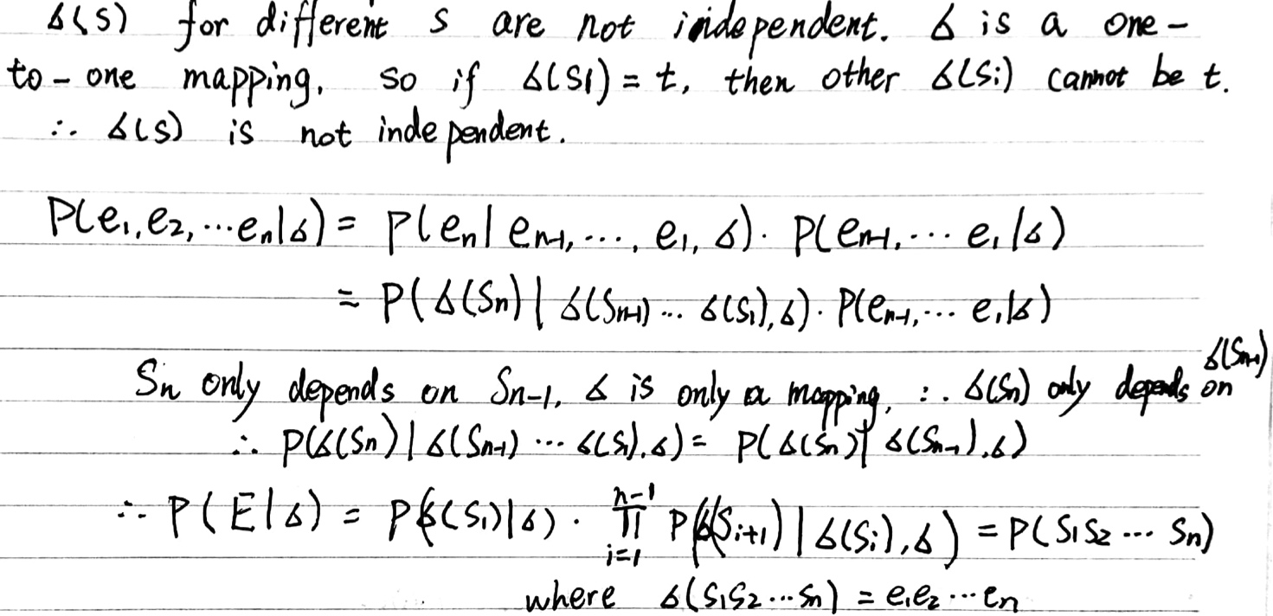

#### (c) Metropolis – Hastings

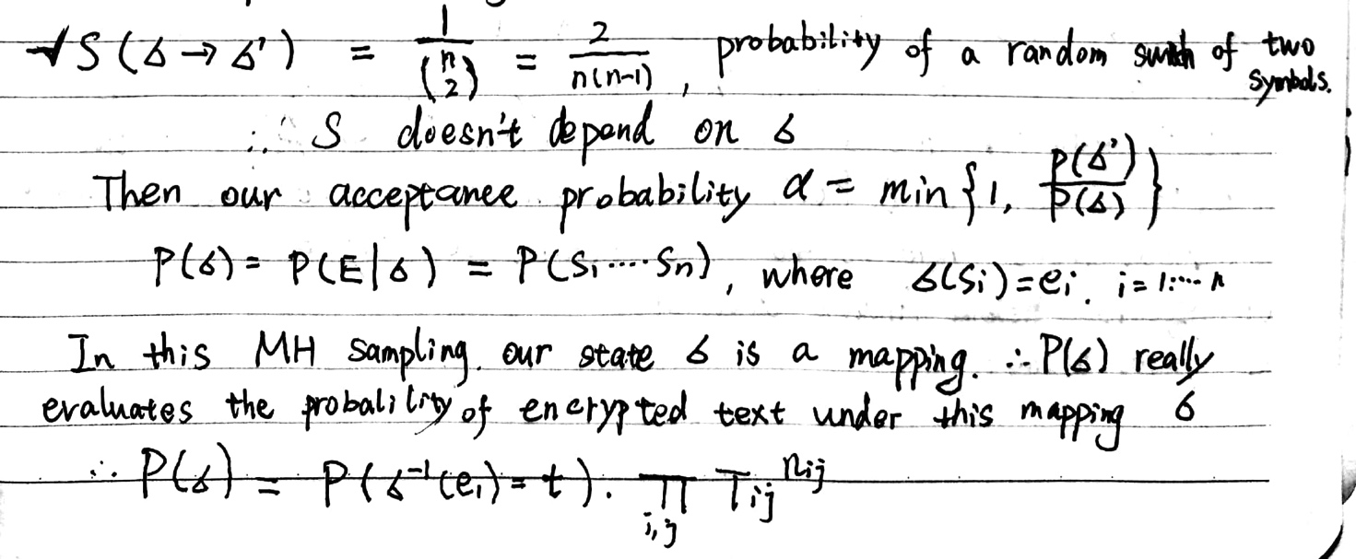

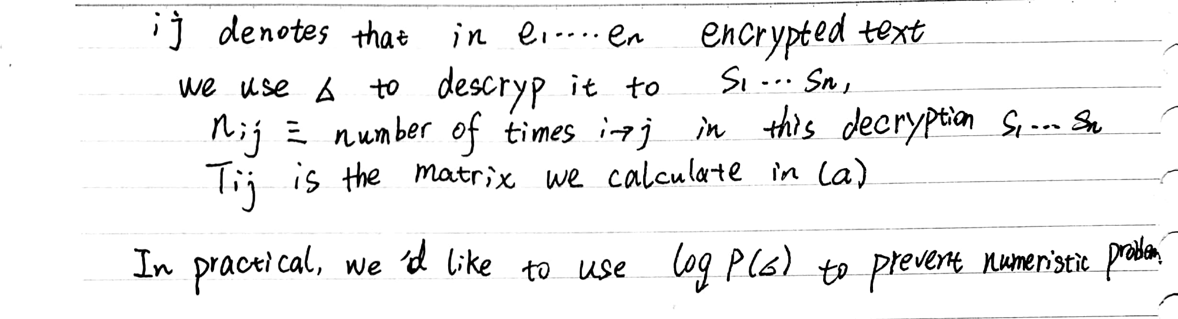

#### (d) Implement MH sampler

Code Parts: partc, generate_sig, get_logscore.

% partc

iteration = 100000;

% read descrypted messages

message=fileread('message.txt');

mlen = length(message);

% initilize the mappings

% we can use some intuitions. such as ' ' and 'e' have the largest

% frequency.

sig = symbols;

distribute = tabulate(message');

fre = [distribute{:,2}]; cha = [distribute{:,1}];

[~,space_pos] = max(fre);

space_map = cha(space_pos);

fre(space_pos)=0;

[~,e_pos] = max(fre);

e_map = cha(e_pos);

sig(find(symbols==' ')) = space_map;

sig(find(symbols==space_map)) = ' ';

sig(find(symbols=='e')) = e_map;

sig(find(symbols==e_map)) = 'e';

% run MH samples

for i=1:iteration

signew = generate_sig(sig);

ls_sig = get_logscore(message,sig,Tnorm,symbols);

ls_signew = get_logscore(message,signew,Tnorm,symbols);

accept = exp(ls_signew-ls_sig);

rand = rand(1);

if rand <= min(accept,1)

sig = signew;

end

if(mod(i,100)==0)

% decoded message

message_d = message;

for k=1:mlen

id = find(sig==message(k));

message_d(k)= symbols(id);

end

display(strcat('iteration ',num2str(i),': ',message_d(1:min(60,mlen))));

end

end

function signew = generate_sig(sig)

signew = sig;

swap1 = randi(length(sig));

swap2 = randi(length(sig));

if swap1==swap2

signew = generate_sig(sig);

else

signew([swap1,swap2]) = signew([swap2,swap1]);

end

end

function ss = get_logscore(message,sigma,T,symbols)

ss = 0;

len = length(message);

for i=1:(len-1)

si = find(sigma==message(i));

sj = find(sigma==message(i+1));

if(si>length(symbols) || sj>length(symbols) || length(si)==0 || length(sj)==0)

else

ss = ss + log(T(si,sj));

end

end

Results:

Some running results:

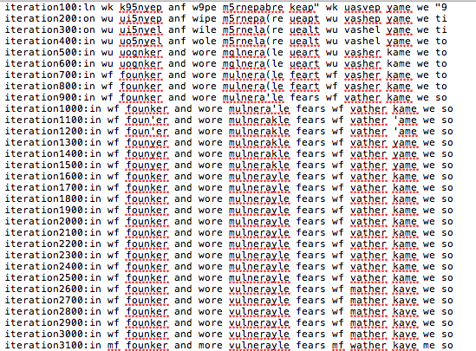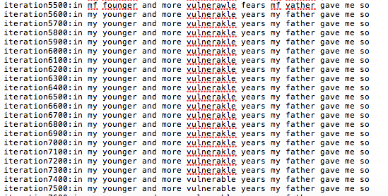

After convergence, we print our decoded text and it gives us a sensible message as below.

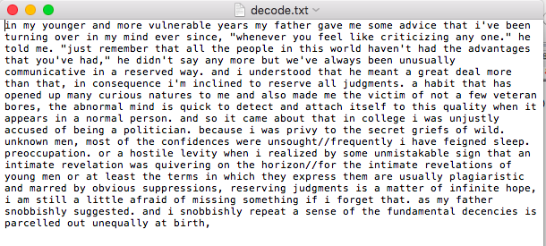

#### Ergodicity

 affects our sampler chain.  means it is impossible to transform from symbol a to symbol b. It our σ maps the encrypted text to some pairs a->b, then the log joint of this σ will be negative infinity. This mapping will not be accepted forever. Also, if two mappings’ log joint all equal to negative infinity, we cannot compare them. So what we do here is to give  a tiny bias.

#### (f) Analyze decoding

Symbol alone: All the symbols will be independent. If the probabilities of symbols are approximate, we cannot distinguish these two letters, then we cannot get a single decryption.

Second order Markov chain: The new transition relationship can be described by a three-dimensional matrix. We can use the same approach to sample our mapping. The mapping space remains the same. This description is more accurate.

Two symbols mapped to the same encrypted value: In this way, we cannot distinguish two symbols from the same encrypted value, which is not a good decoding. However, if we have some prior knowledge about these two symbols (we are confident to distinguish them), then we can map two symbols to the same encrypted value. Actually, this can reduce the sample space and make it converge easier.

Two encrypted values from the same symbol: If there exists one symbol that other symbols probably transform to it and this symbol is likely to stay at itself, like the “space”, then our encrypted values will all be mapped from the same symbol “space”, then decoding makes no sense.

Chinese: doesn’t work any more. To many symbols, the mapping space will be huge, it is hard or it takes a long time to converge to the true mapping.

## 3. Implementing Gibbs sampling for LDA

#### (a) Implement Gibbs Sampling

Code Parts: stdgibbs_logjoint, stdgibbs_update, colgibbs_logjoint,colgibbs_update.

function L = stdgibbs_logjoint(theta,phi,Adk,Bkw,Mk,...

I,D,K,W,di,wi,ci,citest,Id,Iw,Nd,alpha,beta);

% standard gibbs log joint probability over everything

prior_dk = D*(log(gamma(K*alpha))-K*log(gamma(alpha)));

prior_kw = K*(log(gamma(W*beta))-W*log(gamma(beta)));

dk_ll = sum(sum((alpha-1+Adk).*log(theta)));

kw_ll = sum(sum((beta-1+Bkw).*log(phi)));

L = prior_dk + dk_ll + prior_kw + kw_ll;

end

function [zi,theta,phi,Adk,Bkw,Nd,Mk] = stdgibbs_update(zi,theta,phi,Adk,Bkw,Mk,...

I,D,K,W,di,wi,ci,citest,Id,Iw,Nd,alpha,beta);

% standard gibbs update

for ii = 1:I

pii = theta(di(ii),:)' .* phi(:,wi(ii)); % pii is the gibbs sampling conditional distribution

pii = pii/sum(pii); % nomalize pii, should be a k-dim vector

% Resample zi{ii}

ser = mnrnd(1,pii,ci(ii));

[~,index]=max(ser,[],2);

zi{ii} = index';

end

% updata Adk

Adk = zeros(size(Adk));

for ii = 1:I

for k=1:K

Adk(di(ii),k)= Adk(di(ii),k)+sum(zi{ii}==k);

end

end

% Resample doc topic distribution

for d=1:D

theta(d,:) = drchrnd(1,alpha + Adk(d,:));

end

Nd = sum(Adk,2);

% updata Bkw

Bkw = zeros(size(Bkw));

for ii = 1:I

for k=1:K

Bkw(k,wi(ii))= Bkw(k,wi(ii))+sum(zi{ii}==k);

end

end

% Resample topic word distribution

for k=1:K

phi(k,:) = drchrnd(1,beta + Bkw(k,:));

end

Mk = sum(Bkw,2);

end

function L = gibbs_loglik(Adk,Bkw,Mk,...

I,D,K,W,di,wi,ci,citest,Id,Iw,Nd,alpha,beta);

% collapsed gibbs log joint probability over everything

prior_dk = D*(log(gamma(K*alpha))-K*log(gamma(alpha)))-sum(log(gamma(K*alpha+Nd)));

prior_kw = K*(log(gamma(W*beta))-W*log(gamma(beta)))-sum(log(gamma(W*beta+Mk)));

dk_ll = sum(sum(log(gamma(alpha+Adk))));

kw_ll = sum(sum(log(gamma(beta+Bkw))));

L = prior_dk + dk_ll + prior_kw + kw_ll;

end

function [zi,Adk,Bkw,Nd,Mk] = gibbs_update(zi,Adk,Bkw,Mk,...

I,D,K,W,di,wi,ci,citest,Id,Iw,Nd,alpha,beta);

% collapsed gibbs update

for ii = 1:I

pii = zeros(1,K); % pii is the gibbs sampling conditional distribution

for k=1:K

pii(k) = (alpha+Adk(di(ii),k)-sum(zi{ii}==k))*(beta+Bkw(k,wi(ii))-sum(zi{ii}==k))...

/(K*alpha+Nd(di(ii))-sum(zi{ii}==k))/(W*beta+Mk(k)-sum(zi{ii}==k));

end

pii = pii/sum(pii); % nomalize pii, should be a k-dim vector

% Resample zi{ii}

ser = mnrnd(1,pii,ci(ii));

[~,index]=max(ser,[],2);

zi{ii} = index';

end

% update Adk,Bkw,Nd,Mk.

Adk = zeros(size(Adk));

for ii = 1:I

for k=1:K

Adk(di(ii),k)= Adk(di(ii),k)+sum(zi{ii}==k);

end

end

Nd = sum(Adk,2);

Bkw = zeros(size(Bkw));

for ii = 1:I

for k=1:K

Bkw(k,wi(ii))= Bkw(k,wi(ii))+sum(zi{ii}==k);

end

end

Mk = sum(Bkw,2);

end

Results:



#### (b) Implement Gibbs Sampling

For standard Gibbs sampling, we can see that after 24 iterations, both log predictive and joint probabilities  reach a steady level and they just fluctuate around this level. For collapsed Gibbs sampling, this time is 19 iterations. So for standard Gibbs sampling, we discard first 24 iterations. For collapsed one, we discard first 19 iterations. We run for 2000 iterations and calculate autocorrelations as below.



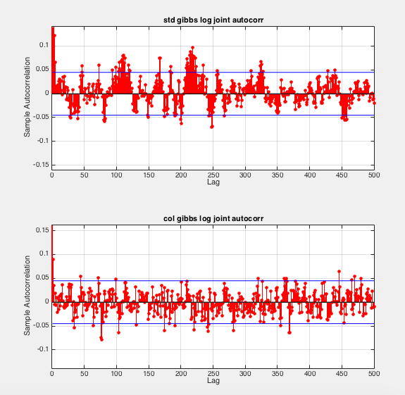

We can notice that there is periodicity for the autocorrelation plots, they go up and go down repeatedly. This is the base frequency of the original joint likelihood arrays, which means our original likelihood arrays also have periodicity. The samples may be in a finite space and transformed regularly. So we need to find out this periodicity.

After some initial values of Lag, we can see that the first time autocorrelation exceeds the confidence bound is when lag is around 50. We can infer that the set of samples from the posterior   recycles after 50 iterations (periodicity is 50). So I think 50 samples can roughly represent the set.

**(c) Convergence**



For part (b), we have observed that collapsed Gibbs sampling reaches a steady level faster than standard Gibbs sampling. For me, this proves collapsed Gibbs sampling converges faster.

To show why this happens, we can look at autocorrelation as below.



As we have discussed in part (b), autocorrelation plots have periodicity. For collapsed Gibbs sampling, this period is smaller. So less samples need to represent the set of samples from the posterior. Then it is faster to transform between these samples.

#### (d) Varying parameters

Varying alpha:





For both log predictive and joint, we can see that smaller alpha gives us larger probabilities. Alpha gives us the prior of theta. Because of the characteristic of Dirichlet distribution, if alpha is bigger, theta is more concentrated (small variance for theta values). If alpha is smaller, theta will possibly scatter in the edges (big variance for theta values). Theta represents document topic distributions. A document normally has some specific topics instead of referring to all the topics. So smaller alpha is more suitable as this prior.

Varying beta:





Beta is totally the same as alpha.

Varying K:



For joint probabilities, K=3 has the largest probabilities. K=2 has the second largest. K=4 is the smallest one. For log predictive, K=3 has the largest probabilities. K=4 has the second largest. K=2 is the smallest one.

Our true data is generated from 3 topics. So there is no doubt that K=3 has the largest probabilities. K=4 is a more complex model compared with K=3. However it doesn’t act well on both sets. Maybe the data is limited, so it is hard to train a converged model for K=4.

#### (e) Prune

Our metric:

Firstly, we use TFIDF to calculate the weights of word i in document j:



Then we choose sum weight matrix over documents. We choose the top 150 weights words as our selected words.

At last, update all the variables such as di, wi, ci… with our selected words.

Code Parts: data_prune, tfidf, tf, idf, remap. function[I,D,K,W,di,wi,ci,citest,Id,Iw,Nd,word_map] = data_prune(W_ex,I,D,K,W,di,wi,ci,citest,Id,Iw,Nd)

% read symbols

fid = fopen('nips.vocab','rb');

words{1} = fgetl(fid);

j=2;

while(~feof(fid))

word = fgetl(fid);

words{j} = word;

j=j+1;

end

fclose(fid);

% generate frequency matrix, times of word w in document d

Freq = zeros(D,W);

for ii=1:I

Freq(di(ii),wi(ii)) = Freq(di(ii),wi(ii))+ci(ii);

end

% using tfidf to calculate weights of words

weights = tfidf(Freq);

tmp = weights;

keep = zeros(W,1);

count = 0;

% selected first W_ex important words

while(count<W_ex)

[~,ddd] = max(sum(tmp));

tmp(:,ddd)=0;

keep(ddd)=1;

count = nnz(keep);

display(words{ddd});

end

% updata I, di, wi, ci, citest

In=0;din=[];win=[];cin=[];citestn=[];

for ii=1:I

if keep(wi(ii))==1

In = In+1;

din = [din di(ii)];

win = [win wi(ii)];

cin = [cin ci(ii)];

citestn = [citestn citest(ii)];

end

end

[win,word_map] = remap(win); % remember the mapping between reduced words and original words

di = din; ci = cin; wi = win; citest = citestn;I=In;

% update other variables

D = max(di);

W = max(wi);

X = sparse(di,wi,1:I,D,W,I);

Id = cell(1,D);

Nd = zeros(1,D);

Iw = cell(1,W);

for ww = 1:W

ii = find(X(:,ww));

Iw{ww} = full(X(ii,ww));

end

X = X';

for dd = 1:D

ii = find(X(:,dd));

Id{dd} = full(X(ii,dd));

Nd(dd) = sum(ci(Id{dd}));

end

end

function [new,word_map] = remap(w)

word=1;word_map=[];

for ww=1:length(w)

if isempty(find(word_map==w(ww)))

word_map(word) = w(ww);

new(ww) = word;

word=word+1;

else

tmp = find(word_map==w(ww));

new(ww) = tmp(1);

end

end

function Y = tfidf( X )

% FUNCTION computes TF-IDF weighted word histograms.

% Y = tfidf( X );

% INPUT : X - document-term matrix (rows represent documents, columns represent words)

% OUTPUT :Y - TF-IDF weighted document-term matrix

% get term frequencies

tf_X = tf(X); % still matrix D*W

% get inverse document frequencies

idf_X = idf(X); % vector, W elements

% apply weights for each document

Y = tf_X;

for j=1:size(X, 2)

Y(:, j) = tf_X(:, j)*idf_X(j);

end

function tf_X = tf(X)

% FUNCTION computes word frequencies

tf_X = zeros(size(X));

for i=1:size(X, 1)

x = X(i, :);

sumX = sum(x);

% tf_X(i, :) = 0.5+0.5*x/max(x);

if sumX ~= 0

tf_X(i, :) = x / sum(x);

else

tf_X(i, :) = 0;

end

end

function I = idf(X)

% FUNCTION computes inverse document frequencies

% m - number of documents

% n - number of words

[m, n]=size(X);

I = zeros(n, 1);

for j=1:n

% count non-zero frequency words

nz = 1 + nnz( X(:, j) );

% if not zero, assign a weight:

if nz

I(j) = log(m/nz) / log(m);

end

end

Result:

We expect 150 words for our model. After pruning, we get “Bayesian”, “Gaussian”, “vector”, “kernel”, “representation”, “regression”, “classification” and other words in our selected words set.

#### Run LDA on NIPS data

We use our default parameters alpha beta and K to do our experiments firstly. For the computation limitations, we iterate 200 times. We plot our log prediction to test our model on the test set. The result is shown as below.

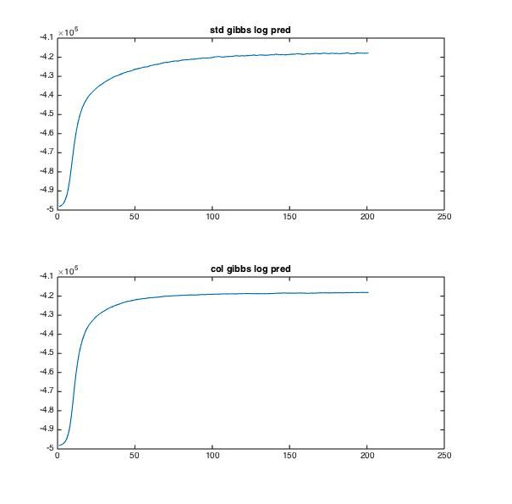

We can see likelihood keeps rising and have a convergence trend. More iteration will make it converge.

We use the following *code* to save our top5 word choices for 50 topics.

tmp = phi;

top5 = zeros(size(phi,1),5);

for i=1:5

[mm,index] = max(tmp,[],2);

top5(:,i) = index;

for k=1:size(phi,1)

tmp(k,index(k))=0;

end

end

fid = fopen('topic-word.txt','wb');

for i=1:size(tw,1)

for j=1:size(tw,2)

fprintf(fid,'%s ',words{tw(i,j)});

end

fprintf(fid,'\r');

end

*Topic word result: (show only several topics)*

prior bayesian distribution data posterior

net network error training weight

model parameter data variables test

gaussian mixture density model likelihood

speech delay auditory temporal signal

data kernel cluster method space

noise gaussian level performance distribution

hmm model recognition speech hidden

neuron network connection synaptic activity

layer hidden input network output

prediction error training regression data

Every line is a topic. We can see our topics do make sense. Some topics represent some specific problems such as regression and classification, other topics represent some methods such as kernel and network and mixture Gaussian.